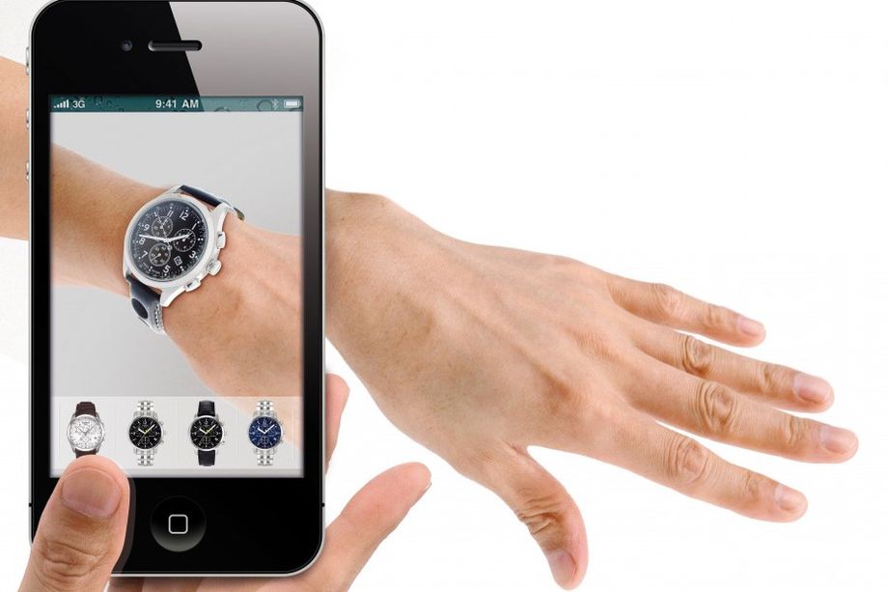

Augmented Sales:

A mobile application for augmented shopping.

Michael Robinson

Study Project

COMP09049

Table of Contents

1.Abstract: 3

2.Aim: 3

3.Initiation. 4

3.1: Concept: 4

3.2: Business Benefit. 4

3.3: Considerations. 4

4.Planning. 5

4.1: Project Plan: 5

4.2: Research: 5

4.3: Analysis: 5

4.4: Design: 6

4.5: Development: 6

4.6: Testing. 6

4.7: Deployment. 6

4.8: Maintenance. 6

4.1 Project Plan. 6

4.1.1: Tasks to be completed. 6

4.2 Research: 8

4.2.1 Current Applications: 8

4.2.2 Products. 9

4.3. Current Methods for Development: 9

4.3.1 AR Development SDK’s: 10

4.3.2 3D Engines. 11

4.3.3 Development choice. 12

4.3.4 Devices. 12

4.3.5 Database. 12

5: Learning the skills. 13

6: Design. 13

6.1 Development life cycle. 13

6.2 Core Functionality. 13

6.3 User interface ideas. 14

6.4 User Interface and program flow chart: 16

7: Development. 17

8. Conclusion: 18

9: Critical Assessment. 18

10. Bibliography: 19

11 Appendix: 20

## 1.Abstract:

Retail has changed over the last few years, it was predicted in 2013 that 62000 shops would fold, and online shopping would account for 22% of retail by 2018, (Royal Bank of Scotland, 2013). With more customers utilising lower prices and faster delivery by shopping via the internet it has become the normal way to shop. Retailers have adapted to this trend by making their products available online and through websites and applications on mobile devices, but customers still have a problem as they won’t know what the item is like in their home until it arrives.

The basis of this study is to produce a mobile application to help educate customers about products and aid them in visualising what that product would look like in their home before they purchase a certain type or style of product. The technology available in mobile devices and the fact that there are over 4 billion devices in the world today (statista.com, 2018) and online sales at £230.62 billion in 2017(Retail Research, 2017), these results identify that this type of application would fit well into this area as it would ensure that the product purchased is correct and that the consumer is confident they have made the right decision in their purchase.

This report will research the current types of applications available, the methods used for developing these applications and examine the best suited products to be utilised by these applications. The results of this research will then be used to design and develop an application of this type.

## 2.Aim:

To develop an application that can be used to aid customers in buying new products. This application will utilise new technologies to create a visual aid into ensuring a product that is being considered would be the perfect product to fit their needs and also help with making an informed decision regarding aesthetics and product features.

Objectives:

* initiation: This will identify the idea behind this project and explore the benefits.
* Planning: This will provide the scope of the project and outline the details.
* Execution: This will be used to allocate resources and identify tasks.
* Control. This will be utilised to indicate the progress of this project.
* Evaluation. This will provide an appraisal of the project and identify next steps.

## 3.Initiation.

### 3.1: Concept:

To create a mobile application that can be used by customers view products using augmented reality. The use of augmented reality will allow customers to see a 3D representation of a product and by utilising products they already own as a marker the 3D image will be projected onto the marker and the customer can then view how the new product would look in their home.

### 3.2: Business Benefit.

The current number of mobile devices in the world today are 4.93 billion, in 2017 this was 4.77 billion and is set to increase to 5.07 billion by 2019 (statista.com, 2018) along with online sales rising from £230.62 billion in 2017 to an estimated 262.46 billion in 2018, (Retail Research, 2017), indicates that more customers are utilising technology to aid them with purchasing the products they require. Online shopping offers lots of advantages from comparing prices, viewing different types of similar products and the ability to compare products and all this can be done from the comfort of their home. Problems arise when a product is misrepresented or what the customer imagines how the product will fit into their lives and in reality, it’s not exactly how they imagined it. This is identified by 30% of current online purchases being returned in comparison to items purchased instore being as low as 8.89%(invescpro, 2017). This identifies that this type of application would provide a visual aid to the consumer and ensure that the correct product is purchased and would in turn reduce the current level of online returns for the retailer.

### 3.3: Considerations.

The application could be used by customers of all ages however with people under the age of 18 online retail regulations need to be adhered to, allowing younger users to use the application should be considered but there should be restrictions incorporated into it to stop them from making purchases justification to allowing them to use it are due to 51% of 12 year olds, 53% of 13 year olds, 72% of 14 year olds, 79% of 15 year olds, 85% of 16 year olds and 84% of 17 year olds use a mobile phone (Pewinternet,2017) this part of the population should be included as they would use it for specific items and so should not be restricted from use. The application should include a disclaimer and if the user is under the age of 16 then the parents’ permission must be provided before it can be used, the application should only store the email address of users under 16 but all other users should provide some personal and payment information for ease of use but information about the users should conform to the regulations of the data protection acts worldwide so that individuals data is not violated and should be in accordance to the DLA Piper worldwide data protection hand book, “Personal data is defined as ‘Any information relating to an identified or identifiable natural person’” (DLA Piper,2017).

## 4.Planning.

### 4.1: Project Plan:

Identify Tasks to be completed.

Create a project plan using a Gantt chart to visualise the timeline required

For each task of the project.

### 4.2: Research:

Examine current applications available.

Investigate which products are best suited to this type of application.

### 4.3: Analysis:

Identify the current software development kits that are available to create this type application.

Investigate the 3D modelling software compatible with the software development kits.

Select which programming language to utilise.

Identify the method that should be utilised to develop this application.

Determine which devices to deploy the application on.

Determine which database management system is most suitable to store

the user, products and other information required by the application.

### 4.4: Design:

Identify requirements of the user interface.

### 4.5: Development:

Create the application.

### 4.6: Testing.

Test the application.

Make recommendations for improving application if bugs are identified.

### 4.7: Deployment.

Deploy the application.

### 4.8: Maintenance.

Maintain the application.

Make recommendations for further development.

## 4.1 Project Plan.

### 4.1.1: Tasks to be completed.

## To create this application, it was decided that a realistic time scale for a project of this size would be 6 months from inception to completion, I identified the following tasks that had to be completed to ensure this would be achievable and the tasks were entered into a Gantt chart so that the project could be managed effectively, and a visual representation could be produced. The tasks were identified as:

* Research: Examine Current Applications, Investigate Products
* Analysis: Identify Current SDKs, investigate 3D Modelling, choose appropriate programming language, Identify the method to use, determine devices and Determine Database.
* Learn Required Skills
* Design: Design the application, design the user interface, design 3D items and Design Database.
* Development: Create application, create user interface, create 3D Objects, create the database and finally combine everything.
* Testing: Design Alpha Test Scenario, test alpha program, make required changes, design beta test Scenario, test beta program,

implement changes, design final test scenario, test final release, and finally implement last minute changes that are required.

* Deployment: Deploy V.1.0 of Application
* Maintenance: Review V.1.0 application, Implement changes, Release v.2.0

# 4.1.2 Gantt Chart.

Using the information identified the planning stage (4.1.1) the following Gantt chart was created to provide an overview of the tasks required and indicate a timeline for when each task should be started by and completed by. A full detailed Gantt chart is located in the appendix.

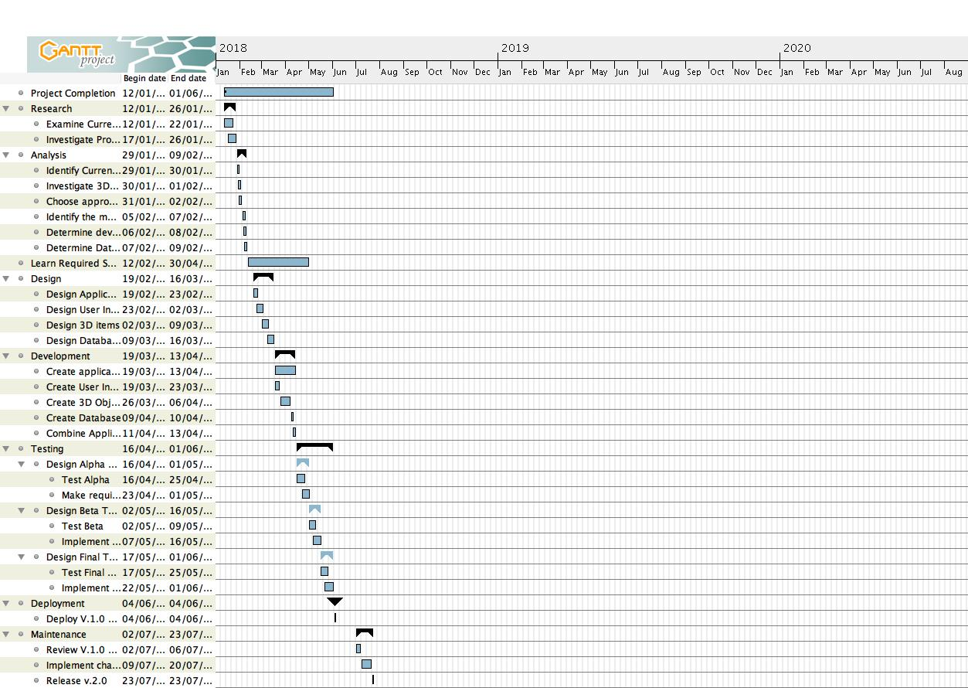

Figure 1: Augmented Sales Gantt Chart.

## 4.2 Research:

### 4.2.1 Current Applications:

There are currently limited applications available that could accomplish what this application will undertake. Ikea has developed and application that will show you in AR what their flat pack furniture would look like when built and placed in your home, Target and Wayfair both American retailers have added AR capabilities to their websites but these are limited in what they offer, during the writing of this report it was announced that Amazon has now released a similar application to what is being developed with this report, it is only available on Apple IOS devices and only accessible in the united states of America and will only feature selected products listed on their website.

These applications do offer similar features, and these can be used as a benchmark for what is the minimal requirements for this application and some considerations should be made during the design stages to not duplicate what is already available.

### 4.2.2 Products.

This application is primarily a tool to aid in the selling of products to consumers visually and by the use of a mobile device, the products that are best suited to this type of sales are varied and the total amount of products are out of the scope of this report so considerations had to be made, a small survey was conducted with retailers and customers and several products were identified to be the best type of products to feature. The results of the survey indicated the following: Furniture, Textiles, Fixtures and fittings, wallpaper, electrical products (kettles, televisions), flooring, fashion and automotive. The results are all valid, but this report will only feature two products, electrical products and wallcoverings but with the scope to include other products in the future.

The choice of actual electrical products that should be featured also had to be considered carefully and from a development perspective it was decided that having the ability to select the relevant wallcovering for a home it would be convenient to see what a new television would look like in contrast the wallcovering selected.

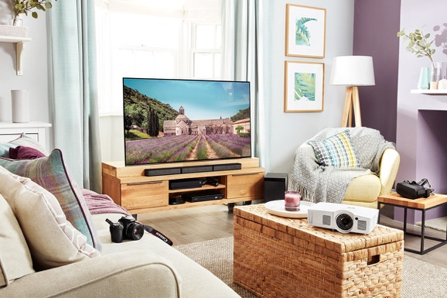

## Figure 2: We’ll help you create a space to relax

Explore our living room to see all the latest entertainment tech you can add to your home.

(currys.co.uk, 02/2018)

## 4.3. Current Methods for Development:

There are several methods available for the development on augmented reality applications each have their own benefits and features. There are numerous software development kits available and far too many to cover in the scope of this report, so it doesn’t cover all software available but to find the best one to create this application this report will examine the top 5 SDKS (Thinkmobiles,2017) (Designnews,2018) and the most common 3D engines that would be used alongside them.

### 4.3.1 AR Development SDK’s:

Vuforia:

This is an augmented reality SDK, it uses Computer Vision Technology to recognise and track image targets by using specific 2D or 3D markers it also includes ‘marker less’ targets to be used, once a target is recognised image registration will then position and orient objects on the screen this can be 3D models or media such as video. (Vuforia.com)

This SDK utilises Unity and incorporates C++ and Java and can be deployed on Android and Apple IOS devices. Currently it has been used to develop 50,000+ applications. (Vuforia.com)

Easy AR:

This is an augmented reality engine and uses Planer image tracking to track and position objects, it also incorporates multi target simultaneous detection and tracking, QR code recognition and transparent video playback and cloud recognition this enables an application to have thousands of targets available in the cloud, it has support for Unity, C++, Objective-C, Java and Swift (EasyAR.com) and can be deployed on Android and Apple IOS.

Wikitude 6:

This is a cross-platform SDK that that combines 3D marker less tracking with object recognition and tracking, it has support for Apples ARKit and Google ARCore and has GEO-Location abilities and cloud recognition. It supports Unity, Blender, Autodesk, Maya3D, C++, Objective-C, Java, JavaScript and can be deployed on Android, Apple IOS and Smartglass. (Wikitude.com, 2018)

ARToolkit:

This is an open-source cross platform SDK, it uses square, 2D barcodes, multi-marker and natural feature tracking. It has support for Unity and openSceneGraph, it uses computer vision techniques to calculate camera position and orientation and uses C and C++ as its primary programming language. (ARToolkit.org,2018)

Apple ARKit:

This SDK is written and supported by Apple and is used to create applications for Apple IOS devices, it features positional tracking to detect the pose of the device, Scene detection to analyse surfaces such as table tops and locate anchor points and face detection, it has support for Unity, Unreal, Metal, SpriteKit and SceneKit and utilises XCode and Swift as its programming language. (Apple.com, 2018).

Google Tango and ARCore:

These Development kits are produced and supported by google and are primarily used on Android devices, Tango was created in 2014 to develop AR apps but the recent release of ARCore (2018), Project Tango will be shutting down. ARcore will utilise technology available in selected mobile devices and features Motion tracking, environmental understanding and light estimation is has support for Unity and Unreal and uses java as its programming language.

Several other SDKs are available however due to the scope of this report they were not examined in detail. The SDKs are Augmenta, Bosch CAP, Kudan, MaxST, XZImg, Microsoft MR (Mixed Reality) and NYARToolkit.

### 4.3.2 3D Engines.

The 3D engines that are most widely used in the development of 3D applications are Unity and Unreal the following is a breakdown of their features (appreal-vr,2017)

Unity:

This is a cross platform game engine that is used to develop 2d and 3d video games, it was initially released in 2005 and has vast support for platforms from mobile devices to Xbox, it supports the latest support for apple ARkit and Google ARCore, it is simple to use and integrate and has support for 2D development too. It utilises C# and JavaScript and has a large community that support it (packpub.com, 2017).

Unreal:

This too is a cross platform game engine and was developed by epic in 1998 for the game unreal, it has now been used widely as a development kit and has lots of built in tools for development of other 3D applications , it does support augmented reality development but this is limited, it uses C++ as its primary programming language but has a unique scripting language called blueprint that allows non-programmers to develop application easily, it also has a well-established community to support it.

When comparing these two 3D engines they are both similar and both would be capable of accomplishing what is required for this application, but this is only one part of what is required, to decide which would be best suited for development of this application the correct choice of SDK along with appropriate 3D engine needs to be decided.

### 4.3.3 Development choice.

After examining all of the available SDKs it was decided that this application should be developed in Vuforia and use Unity as its 3D rendering solution, this was decided for the following reasons. The app needs to be cross platform and to develop the same application on two separate systems would take considerable time so Apple’s ARKit would not be suitable as it would not run on android, ARCore was rejected due to the limited devices it could be used with at the moment. The other SDKs are all very similar in their capabilities, features and would all be suitable but after careful consideration Vuforia came out on top due to its compatibility with both Android and IOS devices, its varied language support and its vast community that has developed around it.

Deciding Vuforia as our choice of SDK it was then taken into consideration which 3D engine to use, this decision was made easier as Vuforia only really supports Unity so this will be the engine that will be used.

Finally, the choice of programming language was decided upon as Java this was chosen due to the project time constraints as a developer I don’t know how to use Vuforia or Unity so I would need to learn these applications but I am familiar with Java so this would reduce the time to learn all the required skills to develop this application.

However, amazon have released Sumerian this is their own Augmented Reality and Virtual reality development kit that combines both a 3D engine and development kit (AWS,2018) and this could be utilised as due to the application being developed is primarily a sales tool, Sumerian has lots of pre-rendered items such as televisions and toasters this could save on time during the development process.

It was finally decided that Vuforia, Unity and Java shall be used to develop this application as support for Sumerian is limited and it is in its infancy, so this was the overall deciding factor to why the final decisions were made.

### 4.3.4 Devices.

The choice of which devices this application would primarily be used with need to be considered, this application is intended to be portable so after examining several options it would be best suited to mobile phones and tablets running either apple IOS and Android, initially it will be developed on an android mobile phone this will also allow android tablets to run the application as it is the same operating system. Later it would be ported over to an apple IOS devices such as iPhone and iPad.

### 4.3.5 Database.

Due to the decision to use Vuforia and Unity the choice of databases needed to be considered after some research into this area I decided to utilise the databases that come with these development kits as use them to store the required data needed by the application, these databases can be local to the device or based in the cloud, so this would be the best choice to save on both time and resources. The databases are limited to the number of items they can store so this will need to be taken into consideration at the design stage of the databases.

## 5: Learning the skills.

As provided in the Gantt chart I allocated myself 4 weeks to learn the required skills to be able to develop this application although I have learned a great deal through research, tutorials, guides and developer websites this time frame was not realistic, I have learned a great deal but will need to keep on developing these skills as I progress through this project. I will develop some of the acquired skills and learn new required skills as I develop this application, so I decided to extend the ‘learning new skills’ section until the end of the project and take a minimum of 3 hours a week to keep abreast of the needs of this project.

## 6: Design.

The following stages were used to design the application.

* Development life cycle.
* Core Functionality.
* User interface ideas.
* User interface and program flowchart.
* Create 3D images.
* Database Design.

### 6.1 Development life cycle.

The most apparent design method to utilise would be the waterfall method as this allows testing and analysis which would be required when nearing the end of the project.

### 6.2 Core Functionality.

The core functionality of this application is to use the camera of the user’s device to locate a marker, this marker will be chosen by the user in the form of a product, once the camera has detected the marker then a 3D generated image will be super imposed over the top of the marker. The user can then see the ‘virtual’ item displayed via the devices screen.

These functions were to be accessed using a simple and easy to use interface and the design of this interface is featured in the following section, this application would then allow the user to select more information about the product and also allow the user to purchase the product if they wish so I developed a program flow diagram for both the interface and application.

### 

### 6.3 User interface ideas.

Here are the mock up screen shots for the application, the interface will consist of 4 buttons, a select product button which will take you to the product selection page, a more information button which will display the additional information about the product, a buy product button which will take the user a checkout screen and a quit button that will exit the application.

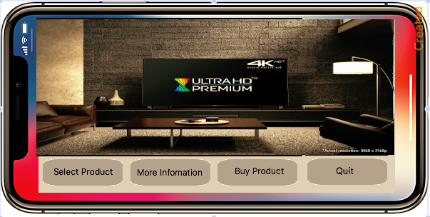

Figure 3: Mock-up of application for a mobile phone

(Main Page)

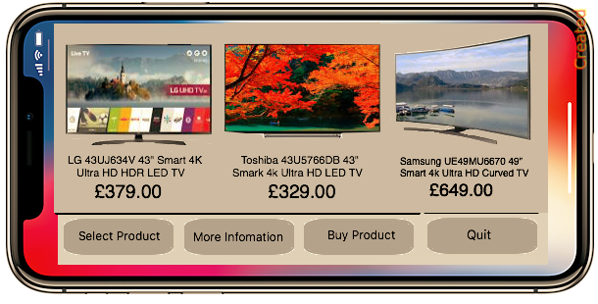

Figure 4: Mock-up of application for a mobile phone

(Product selection)

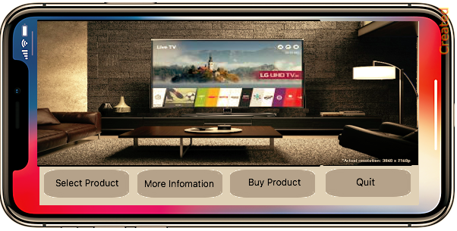

Figure 5: Mock-up of application for a mobile phone

(Image overlay)

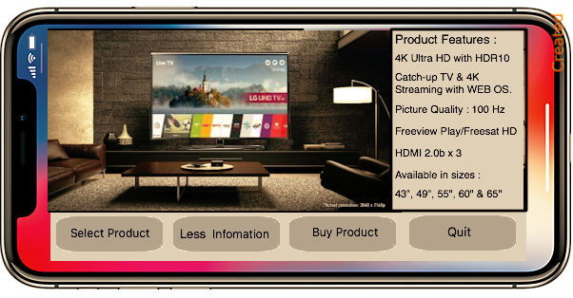

Figure 6: Mock-up of application for a mobile phone

(More Information)

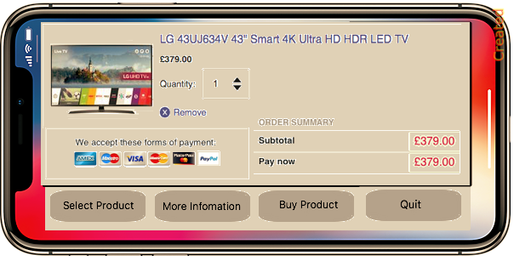

Figure 7: Mock-up of application for a mobile phone

(Checkout Page)

The design of the interface is of upmost importance as usability is measured by “the extent to which the intended goals of use of the overall system are achieved (effectiveness); the resources that have to be ex-pended to achieve the intended goals (efficiency); and the extent to which the user finds the overall system acceptable” (Reinhard Oppermann ,2002).

It should also consider of the following, “during interaction, a user performs cognitive, physical, and sensory actions and requires affordances to help with each”

(H. REX HARTSON,2003).

An online survey of popular applications (Olson,Salo,2011) revealed that applications with useful content, good interaction with the application and user interface were identified as the greatest strengths so it will be adopted that this application and should utilise a very simple and easy to use interface and give clear instructions and features rich.

### 6.4 User Interface and program flow chart:

The flowchart below shows how the application should flow when the application is stared it indicates how simple it is to use and also how easy it is to return to the home screen from any point in the application.

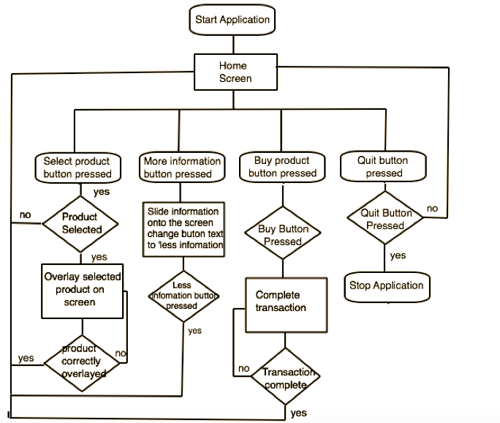

## 7: Development.

Due to the time limitations of this project the development of this application is still in its infancy and a basic prototype has been created. This version has the buttons present on the screen while the camera is operating, it allows the user to select a tv image from a menu that appears when the ‘select product’ button is pressed, and will display a tv image in full size when the application picks up the marker, it also allows the user to view information about each product via panel that appears and disappears when the information button is pressed and finally allows a product to be added to a basket and purchased however this is just a dummy panel and only for authenticity to demonstrate what could be developed further in the future. This prototype has only been tested on an i

iPad mini and works well it was also tested on an iPhone 8+ and was working before apple released an update and this has caused issues with unity at the moment with this model, I will however keep developing this application as per the gannt chart and hopefully have a fully working version available by the predicted project end date.



## 

## The marker used so the application could overlay the image.

## 8. Conclusion:

The prototype created was very primitive but was an insight into how this technology could be and is currently being used in the sales industry, Augmented reality will be present in our everyday life from games to medical applications, This sales tool could bring a big change to how products are purchased in the future, hopefully the mock up design and the working prototype are an indication of what could be developed in the future.

## 9: Critical Assessment.

Throughout the duration of this study project I found myself wanting to learn more about this technology and have become fascinated by the types of applications that are being developed, this project has enabled me to look in depth into what it is like to manage a project from the beginning and understand the steps required to successfully develop an application, I did find that at different stages throughout this course that I did not give myself enough time to complete certain tasks for example giving myself 4 weeks to learn the skills required was a great underestimate and I feel that learning this technology would take much longer than I anticipated and with the changes that are constantly being made in this area further learning is going to be required. I did however find that my previous subjects that I have studied during my degree have helped immensely as I have found I have utilised the skills I learned from the research methods module to aid me with the research required for this one, the understanding of how mobile devices work and how programs flow from the mobile applications development module, used knowledge I have learned in algorithms and collections module with the Java code required for the application scripts to work when using unity and I will use the UML skills when I develop this application further.

## 10. Bibliography:

Royal Bank of Scotland (2013) [online]

<https://www.rbs.co.uk/>content/coporate/downloads/2013RBS_Retail_Report.pdf

[Accessed 19/01/2018]

Retail Research (2018) [online]

<http://www.retailresearch.org/onlineretailing.php>

[Accessed 19/01/2018]

Statista (2018) [online]

<https://www.statista.com/statistics/274774/forecast-of-mobile-phone-users-worldwide/>

[Accessed 19/01/2018]

Pewinternet (2017)[online]

<http://www.pewinternet.org/2009/08/19/teens-and-mobile-phones-over-the-past-five-years-pew-internet-looks-back/>

[Accessed 19/01/2018]

Thinkmobiles (2017)[online]

<https://thinkmobiles.com/blog/best-ar-sdk-review/>

[accessed 26/01/2018]

Design News(2018)[online]

<https://www.designnews.com/design-hardware-software/10-best-augmented-reality-software-development-kits>

[accessed 26/01/18]

Thomas Olsson, Markus Salo (2011)

Online User Survey on Current Mobile Augmented Reality Applications

IEEE International Symposium on Mixed and Augmented Reality 2011, Science and Technology Proceedings, Pages 79 -84

Andre Charland, Brian LeRoux. (2011)

mobile application Development: Web vs. native

Communications of the ACM, Volume 54, Issue 5, Pages 49-53

# 10.1 Image Sources:

Cover Image: <https://www.recode.net/2016/2/1/11587458/the-augmented-reality-enterprise-opportunity>

UWS Logo: [www.uws.ac.uk](http://www.uws.ac.uk)

iPhone X: [www.apple.com](http://www.apple.com)

Television Room: <https://www.flatpanelshd.com/article.php?subaction=showfull&id=1456744818>

Television images: [www.currys.co.uk](http://www.currys.co.uk)

Marker image: [doi.ieeecomputersociety.org](http://doi.ieeecomputersociety.org/10.1109/TVCG.2010.91)

## 11 Appendix:

The survey questionnaire.



Augmented Sales:

A mobile application for augmented shopping

We're conducting research on augmented reality, this is a way of making virtual items appear in the real world using a mobile device, the most popular application currently that uses this technology is Pokémon GO. This survey is to identify if this technology would be useful as a selling tool with the intention of designing an application that will aid in this field of sales.

We'd like to identify from you what experience you have of augmented reality and whether you would consider using an application to view products before you purchase them.

The survey should only take 2 minutes, and your responses are completely anonymous and no personal information will be required.

You can only take the survey once.

Questions marked with an asterisk (*) are required.

This survey will only be used as part of the study project coursework,

and will not be used for any other purpose.

If you have any questions about the survey, please email us: [B00278705@studentmail.uws.ac.uk](mailto:B00278705@studentmail.uws.ac.uk)

We really appreciate your time thank you!

**Your response to the survey is voluntary.**

* Are you aware of augmented reality? (*) YES / NO
* Would you consider buying products virtually? (*) YES / NO
* Do you use an app to purchase items? (*) YES / NO

(EBay, Amazon, Curry’s, Ikea etc.).

* Would you like to visualise a product before you buy? (*) YES/NO
* Have you ever used an augmented reality app (*) YES / NO

Thank you for taking the time to complete this survey.